Smart Shopping Cart using IOT &
Google Firebase

Kapil Wagh
Department of Information Technology
Assistant Professor, Nutan Maharashtra Institute of Engineering and Technology, Talegaon-Pune
Maharashtra,India
kapilwagh2686@gmail.com
0000000277416050

Yash Virendra Upare
Department of Information Technology
Nutan Maharashtra Institute of Engineering and Technology, Talegaon-Pune
Maharashtra,India
yashupare6133@gmail.com
0009000874136839

Saurabh Umesh Pisal
Department of Information Technology
Nutan Maharashtra Institute of Engineering and Technology, Talegaon-Pune
Maharashtra,India
saurabhpisal25@gmail.com
0009000524437981

Vinit Ajit Dhas
Department of Information Technology
Nutan Maharashtra Institute of Engineering and Technology, Talegaon-Pune
Maharashtra,India
dhasvinit1@gmail.com
0009000756631935

Aditya Manoj Bole
Department of Information Technology
Nutan Maharashtra Institute of Engineering and Technology, Talegaon-Pune
Maharashtra,India
adityabole01@gmail.com
0009000309770845

Abstract— In the modern shopping landscape of the 21st century, many families enjoy the experience of visiting stores and boutiques. Traditionally, shoppers fill their carts with items and then face long waits at checkout lines. To enhance this experience, we have developed an innovative solution: The Smart Shopping Cart. This system incorporates RFID technology, allowing customers to scan products as they shop. The RFID reader embedded in the cart communicates with an Android mobile application, providing real-time updates of the total cost of items selected. Additionally, the system can send notifications to customers’ mobile devices, helping them stay informed about their spending. By automating cart navigation and improving checkout efficiency, this project not only minimizes wait times but also facilitates better budget management during shopping. Key features include automated cart movement, personalized shopping recommendations, and integration with marketing technologies, all aimed at transforming the retail experience.
Introduction
Technology continually inspires new ideas and fosters global connections, especially through innovations like the Internet of Things and business automation. From the dawn of scientific advancement, the focus has been on alleviating challenges and enhancing productivity. One of the popular pastimes today is shopping, whether in large stores or small boutiques. This calls for innovations in the shopping experience, leading to the concept of a smart store.
In this model, customers can register using their phone numbers, enabling a seamless purchasing process with real-time billing. This feature allows shoppers to monitor their expenses throughout their visit, eliminating the hassle of long queues. Products are scanned and added to the cart using an RFID reader, with additional information displayed on an LCD screen.
To enhance convenience, the cart is equipped with ultrasonic sensors for automatic navigation, managed by an Arduino microcontroller and motors. Additionally, a GSM module connects the cart to the user's mobile device, ensuring that upon payment completion, a detailed message outlining the total cost is sent directly to the customer’s phone. This integrated approach not only streamlines the shopping experience but also empowers customers to manage their budgets more effectively.
Literature Survey
- Paper Name -: Automated billing using advanced cart
Author -: Chandrasekar Palanisamy, T. Sangita
Analysis-: In this article [1], they made a prototype that every car will be attched with an RFID reader and a RFID receiver. In addition, all products in the store or market will be equipped with RFID tags. Supermarkets are places where consumers buy and pay charges for products which they use daily. For this, it is necessary to calculate the stock and determine the price according to the customer. When we go shopping in the market, we should choose the right products carefully. Then it is busy with the invoices of all the products. Therefore, a system has been prepared to help customers trade smartly. There is an RFID tag that the user can swipe on the RFID scanner and when the swipe is completed, it will get the product ID. Product IDs will be included in the file as an additional fee in the invoice. The recommendations are based on the products in the shopping cart. Recommendations are based on the customer's past purchase history and are presented based on the recommendation. Payment can also be made with an RFID tag added to the cart. The disadvantage is that you cannot pay online, you have to wait in line, and the price is high.
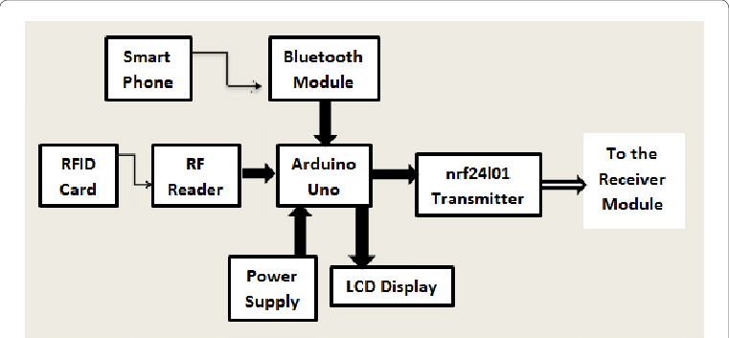
Fig 1. Smart Cart with Automatic Billing

[2] Paper Name-:Collaborative Product Recommendation System for E-commerce Websites
Author-: S. Ganesh Sundaram
Publisher-: IEEE
Analysis-: Product information is important in convincing customers to buy the right product on any e-commerce site. User reviews on the internet are based on the experience of each user and this will be more important information for people. Tips about price, performance, previous purchase signals etc. are important. In this article, we aim to improve the quality of service providers by comparing the reputation scores of each category of specific products on various e-commerce sites. Finally, the number of products can be reduced to one-third of the total product to reach a group of people who are interested in buying the product. Finally, only a few products are suggested to users on a five-point scale, allowing users to filter and purchase them.
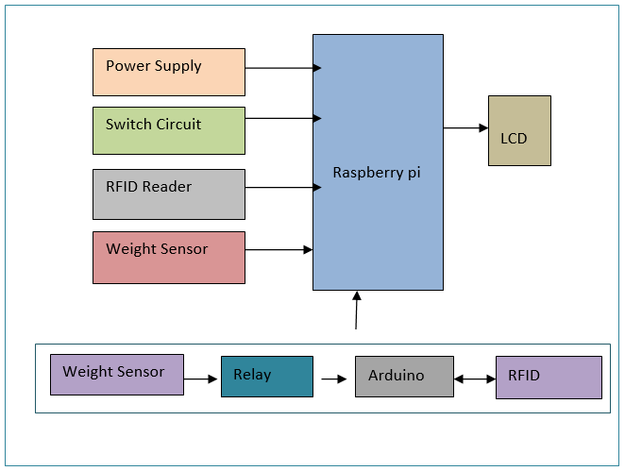
Fig 2. Collaborative Product Recommendation System

[3] Paper Name-: The automated shopping trolley for supermarket billing system
Author-:Sainath (2014)
Analysis: Customers leverage barcode technology to check product prices by scanning items at the point of sale. After scanning, the product details are sent to the billing system, allowing customers to complete their payment by entering a unique identification code. However, one limitation of barcode scanning is its requirement for a direct line of sight; the scanner must be aligned properly with the barcode to function, which can pose challenges in certain settings. This dependency on visibility can affect the speed and efficiency of transactions in busy environments.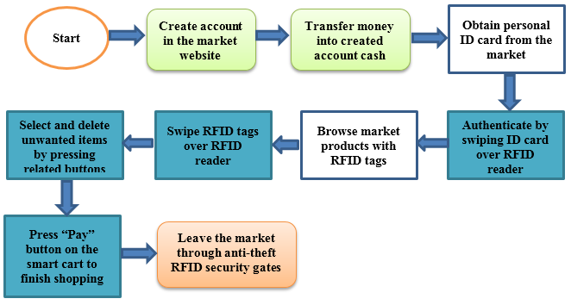
Fig 3. Automated shopping trolley

[4] Paper Name-: Cash register line optimization system using RFID technology.
Analysis: RFID technology facilitates the scanning of products, with data being recorded in a database that allows for online payments or transactions through a centralized payment system. A dedicated website is utilized to oversee all aspects of the purchasing process, making it essential to maintain web application servers effectively. However, there is often a lack of focus on tracking which specific items customers add to their carts or discard, which could impact inventory management and user experience.
[5] Paper Name-: Smart shopping cart based on Internet of Things
Author -: Dhavale Shraddha (2016)
Analysis: This article explores the application of RFID technology for facilitating payments during in-store purchases, complemented by an Internet-based price management system utilizing the ESP module. The payment information is transmitted from a central payment processing hub to a server, which allows customers to finalize their transactions. The ESP module functions as a compact Wi-Fi chip, enabling seamless wireless communication.
However, there are notable challenges associated with this system. Limitations in range and potential interference can affect performance. Additionally, during peak shopping times, high customer volume may overwhelm the server, leading to potential delays. A reliable network connection is crucial for ensuring that transactions are completed smoothly.

[6] Paper Name-: Smart shopping cart using RFID
Author: Komal Ambekar (2015)
Analysis: Customers utilize barcode technology to scan items for pricing during their shopping experience. Once scanned, the product information is transmitted to a billing system, where the customer can complete their payment by providing a unique identifier. However, barcode scanning has its limitations; it requires a direct line of sight to function effectively, meaning the scanner must be positioned correctly to read the barcode accurately. This restriction can hinder efficiency in certain shopping environments.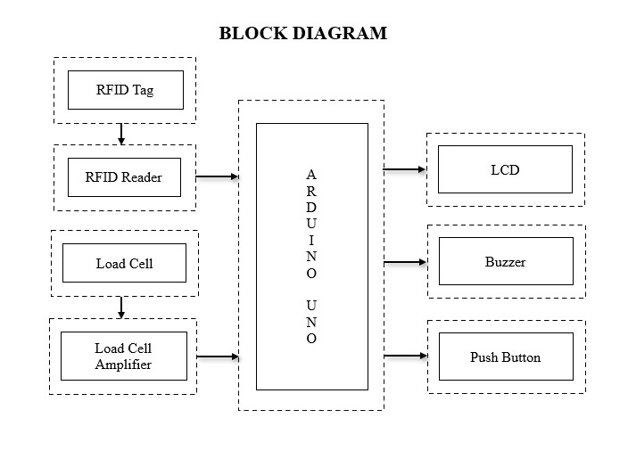
Fig 4. Smart Shopping Cart RFID

[7] Article Title-: Customer-Oriented Big Car
Author: Hsin-Han Jiang (2016),
Observation: This article discusses the use of non-standard technologies for automatic payment systems that rely on facial recognition for customer identity verification. Implementing such a system can be challenging in crowded stores, where accurately recognizing faces may be difficult. Additionally, errors can arise from measurement inaccuracies when utilizing RFID for sales transactions. The system employs a dedicated website for billing and user interactions, allowing each customer with a unique ID to access their billing information. However, the reliability of this service hinges on stable network connectivity, and disruptions can lead to transaction failures or server overload.
Observation: the article mentions the reliance on default values on the server side, where RFID is used to scan products, generate invoices, and link them to customers. This process necessitates robust server maintenance and a stable network connection for both customers and store owners. It also highlights the importance of completing transactions and updating prices in the shopping cart. Connectivity to users’ Android devices via Bluetooth is required, yet not all customers possess smartphones, and Bluetooth connectivity can be inconsistent. The Suganya Autonomous Smart Trolley, which facilitates smart billing using Arduino technology, exemplifies the integration of business automation and Android applications. However, it underscores a limitation, as not all customers may have access to Android devices or reliable network connections.
Observation-: This article describes a smart trolley that can use RFID tags to track purchases and payments. It will scan the shopping cart for payment and checkout. In today's world, shopping has become a daily chore. We can see long queues waiting to pay in many stores. The aim of our project is to overcome errors and prevent time loss. To overcome the above problems, we propose a smart cart that can scan products and make online payment using RFID tags. It automatically recognizes and recognizes the product and the final payment is done by the shopping cart itself. Therefore, customers do not need to wait for a long time. It also has RFID-based power management. This model is necessary and useful for the new functioning of the Internet of Things in smart cars. The main purpose is to provide a tool, save time and create a business-oriented product. The system will also provide product recommendations based on the customer's purchase history. In our project, we will attach an RFID tag to each product in each shopping cart. These features will save time and make shopping easier. We can have the best overall shopping experience.

System ARCHICTECTURE
We will use ESP32 which will be connected to android app using Bluetooth
Hardware will be develop using Ultrasonic sensor and RFID scanner/reader. Whenever user put the product in trolley it will send notification to android app.
Price will be updated on the android app
User will register using the android app where they fill the personal details.
Checkout of product will be done using google pay
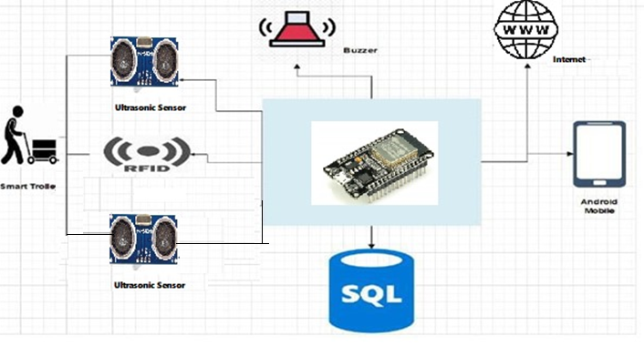
Fig 1. Architecture Diagram

ModULE
A. User Account Setup and Authentication
Account Creation: Users need to register by creating an account within the application.
Information Storage: All user details will be securely stored on a dedicated web server.
B. Shop Database Structure
Product Information: The database will hold comprehensive details about each product offered in the shop.
User and Payment Data: Information related to user accounts and payment transactions will also be included in this database.
C. Shopping Cart Selection Process
Post-Login Procedure: After successfully logging in, users will receive a prompt to scan for available shopping carts.
Cart Identification: Each cart will be recognized by a unique SSID following a designated format.
Choosing a Cart: Once the scanning is complete, users can choose their desired cart.

RESULT
After developing a hardware prototype and software this is how our project looks like .

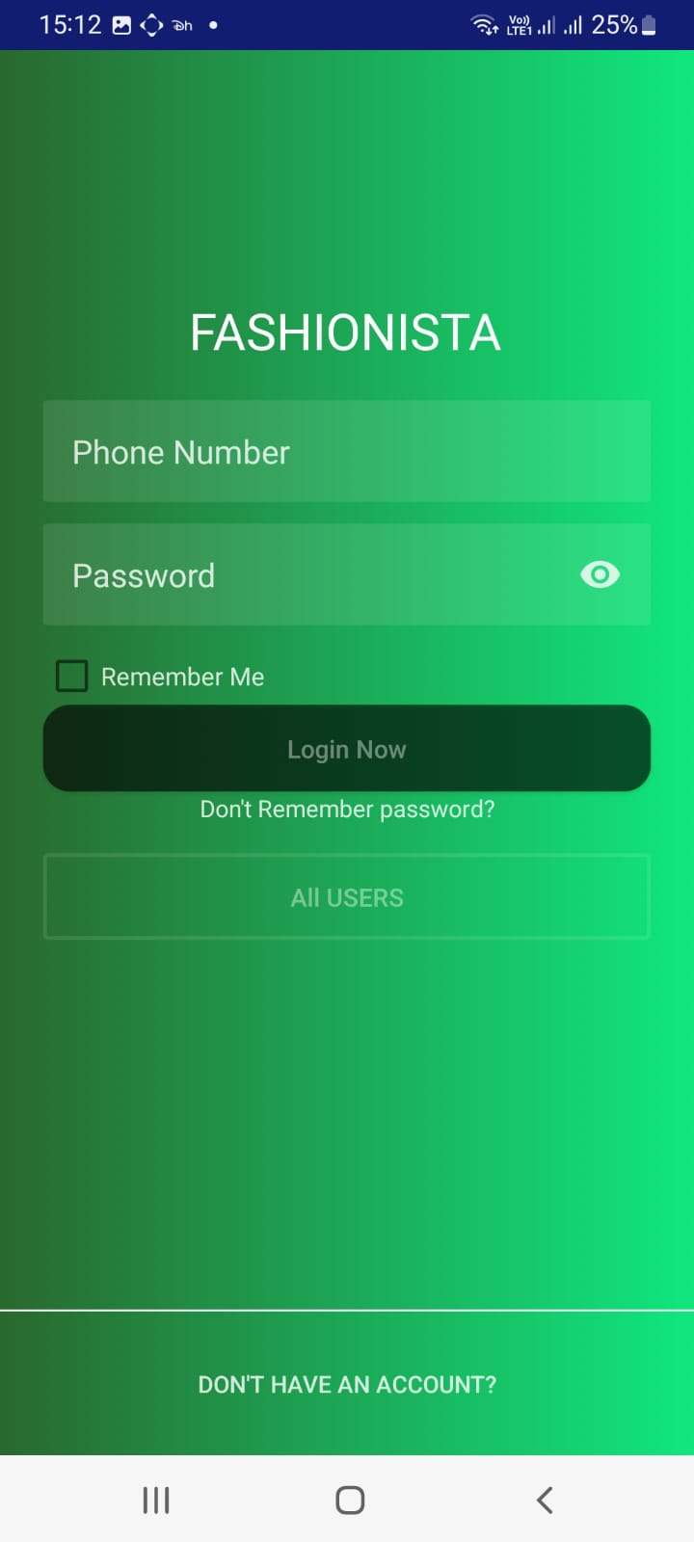
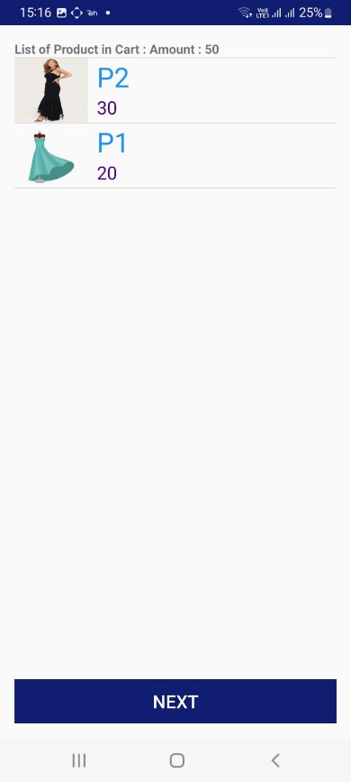

Conclusion

Overall, the development of this system is a major achievement in sales technology. This innovative solution combines the convenience of electronic billing with the power of real-time product data and personalized recommendations, ultimately improving the customer experience. Not only does it simplify the checkout process, save customers time, and reduce errors, but it also provides rich product information that supports informed purchasing decisions. It also uses advanced algorithms and data analytics to match product recommendations, provide personalized preferences, and engage shoppers. The combination of these capabilities makes smart shopping carts a great solution for both merchants and consumers, optimizing the retail ecosystem while improving the products people use.

References
[1] Mr. Manikandan and Mr. Mohan “RFID Based Shopping Trolley for Supermarket”, JCHPS,8 June 2022.

[2] Mr. S. Balamurugan and Mr. S. Balaji “Smart Shopping Cart”, International Conference on Microelectronic Devic es, Circuits and Systems (ICMDCS) 10-12 August 2021

[3] Mr. Kumar and Mr. Gupta. A “Smart Trolley using Arduino”, International Journal of Advanced Research in Computer Engineering & Technology (IJARCET),12 December 2020.

[4] A. Yewatkar, F. Inamdar, R. Singh, Ayushya and A. Bandal, Smart cart with Automatic Billing, Product Information, Product Recommendation Using RFID & Zigbee with Anti-Theft”, Proceedings of 7th international conference on communication, computing and virtualization, Procedia computer science, 79(2016), pp.793-800

[5] D. P. Acharjya and T. K. Das, “A framework for attribute selection in marketing using rough computing and formal concept analysis”, IIMB Management Review, Vol. 29, pp.122–135, 2017. [3] G. Roussos, “Enabling RFID in retail”, Computer, Vol. 39, No. 3, pp. 25-30, 2006.

[6] H. H. Chiang et al., “Development of smart shopping carts with customer-oriented service”, in proc. of International Conference on System Science and Engineering, Taiwan, pp. 1-2, 2016.

[7] L. Yathisha, A. Abhishek, R. Harshith, S. R. D. Koundinya and K. M. Srinidhi, “Automation of shopping cart to ease queues in malls using RFID”, International Research Journal of Engineering and Technology, Vol. 2, No.3, pp.1435-1441, 2015.

[8] S. Sojitra1 and R. G. Patel, “A Review of Smart Shopping Systems”, International Research Journal of Engineering and Technology, Vol. 3, No. 5, pp. 2561-2563, 2016.

[9] S. Kamble, S. Meshram, R. Thokal and R. Gakre, “Developing a Multitasking Shopping Trolley Based on RFID Technology”, International Journal of Soft Computing and Engineering, Vol.3, No.6, pp.179-183.2014

[10] T. K. Das, “A Customer Classification Prediction Model Based on Machine Learning Techniques”, in proceedings of IEEE International Conference on Applied and Theoretical Computing and Communication Technology, pp. 321-326, 2015.

[11] T. Nakahara and K. Yada “Evaluation of the Shopping Path to Distinguish Customers Using a RFID Dataset”. International Journal of Organizational and Collective Intelligence archive, Vol. 2, No.4, pp. 1-14. 2011

[12] Y. Kambayashi, Y. Harada, O. Sato, and M. Takimoto, “Design of an intelligent cart system for common airports”, Consumer Electronics, ISCE \'09. IEEE 13th International Symposium, pp.523-526, 2009.

[13] Z. Ali and R. Sonkusare, “RFID Based Smart Shopping and Billing”, International Journal of Advanced Research in Computer and Communication Engineering, Vol. 2, No.12, pp. 4696-4699.2013

